ASSIGNMENT- 4

#include "BluetoothSerial.h"

int trigpin=5;

int echopin=4;

BluetoothSerial SerialBT;

void setup() {

// put your setup code here, to run once:

pinMode(22,OUTPUT);

Serial.begin(115200);

Serial.println("data");

delay(3000);

SerialBT.begin("ESP32test"); //Bluetooth device name

Serial.println("The device has started, now you can pair it with bluetooth!");

pinMode(echopin,INPUT);

pinMode(trigpin,OUTPUT);

}

void loop() {

// put your main code here, to run repeatedly:

if (Serial.available()) {

SerialBT.write(Serial.read());

}

if (SerialBT.available()) {

Serial.write(SerialBT.read());

}

digitalWrite(trigpin,HIGH);

delay(1000);

digitalWrite(trigpin,LOW);

int duration=pulseIn(echopin,HIGH);

int level=duration*0.0343/2;

if(level<200)

{

Serial.print("the water level is");

Serial.println(level);

SerialBT.print(level);

digitalWrite(22,HIGH); // turn the LED on (HIGH is the voltage level)

Serial.println("the water supply is on");

delay(1000);

}

else

{

digitalWrite(22, LOW); // turn the LED off by making the voltage LOW

Serial.print("the water supply is off");

delay(1000);

}

delay(1000);

}

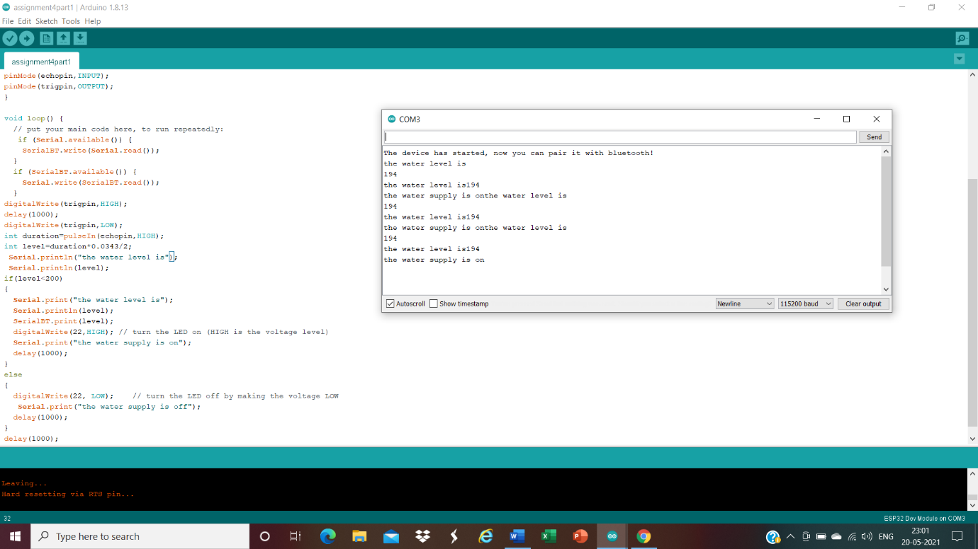

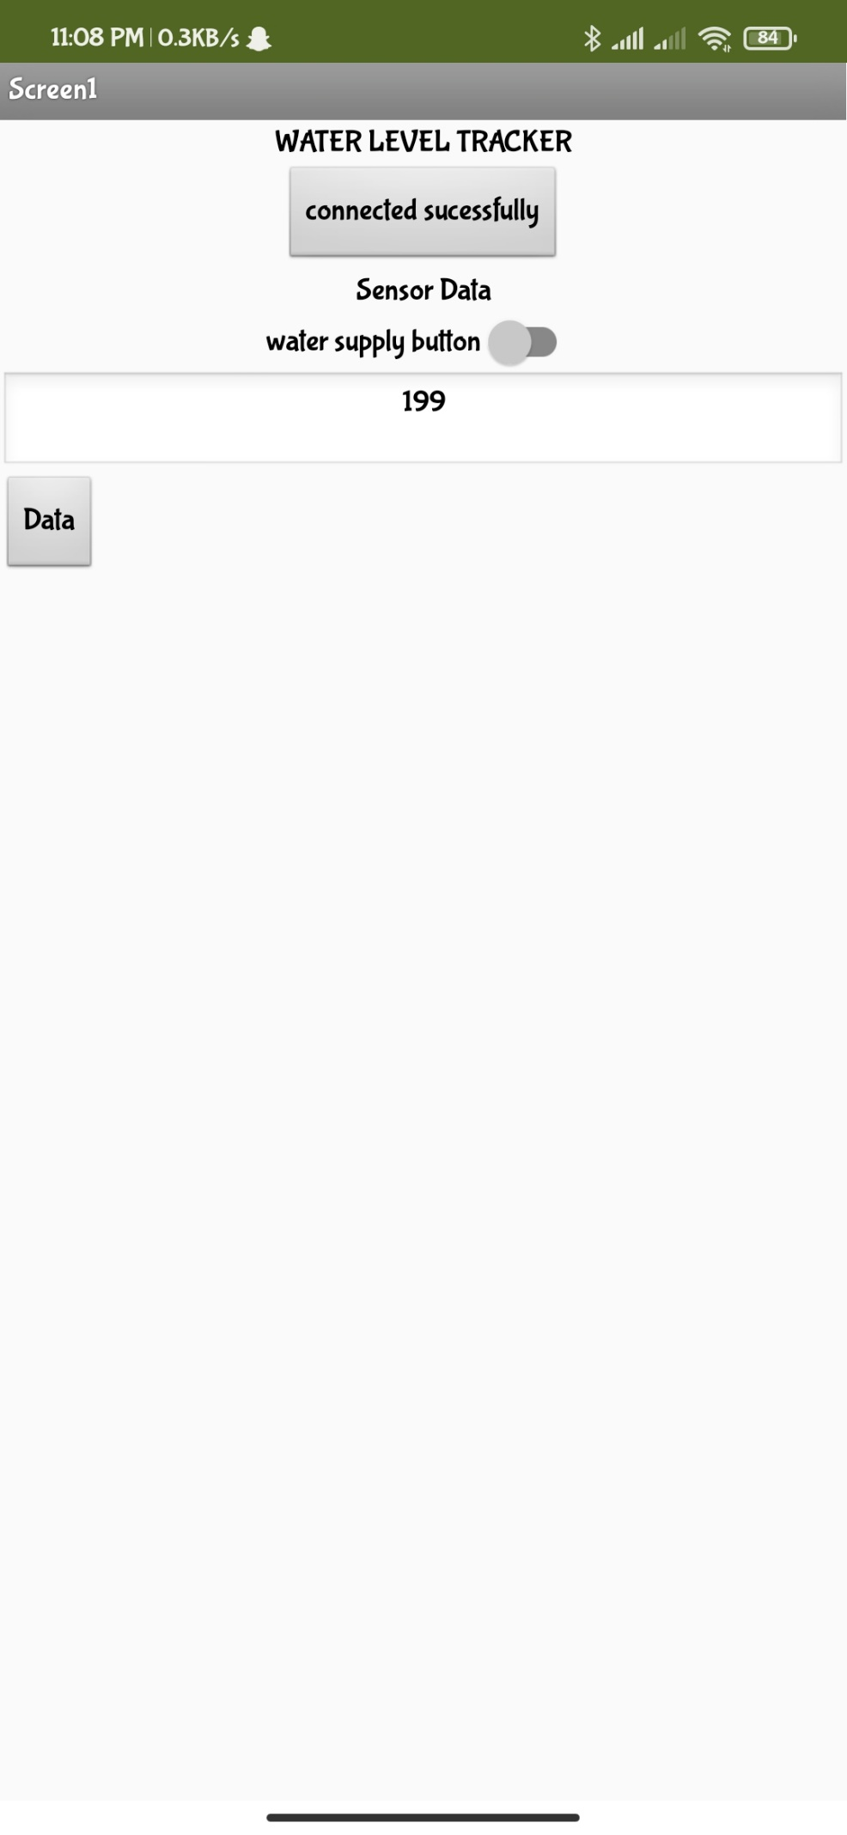

#include "BluetoothSerial.h"

#if !defined(CONFIG_BT_ENABLED) || !defined(CONFIG_BLUEDROID_ENABLED)

#error Bluetooth is not enabled! Please run `make menuconfig` to and enable it

#endif

BluetoothSerial SerialBT;

int option;

char waterflow;

const char turnON ='k';

const char turnOFF ='n';

const int LEDpin = 2;

void setup() {

Serial.begin(115200);

SerialBT.begin("ESP32");

Serial.println("The device started, now you can pair it with bluetooth!");

Serial.println("To turn ON PUMP: k");

Serial.println("To turn OFF PUMP: n");

pinMode(LEDpin, OUTPUT);

}

void loop() {

waterflow =(char)SerialBT.read();

if (Serial.available()) {

SerialBT.write(Serial.read());

}

if (SerialBT.available()) {

SerialBT.println("the option opted is");

SerialBT.println(waterflow);

Serial.print ("the option opted is ");

Serial.println(waterflow);

if(waterflow == turnON)

{

SerialBT.println(" THE PUMP IS ON:");

Serial.println("THE PUMP IS ON:");

digitalWrite(LEDpin, HIGH);

}

if(waterflow == turnOFF)

{

SerialBT.println("THE PUMP IS OFF:");

Serial.println("THE PUMP IS OFF:");

digitalWrite(LEDpin, LOW);

}

}

delay(20);

}

